The Village of Pleasantville Conservation Advisory Council (CAC) is hosting three talks through the Mount Pleasant Library in the upcoming weeks.

The first talk is this Thursday, April 29th from 7-8pm

**"Attracting Pollinators to your Yard"**

Pollinator and bird populations have suffered dramatic declines in the past 50 years due to habitat loss, changing climates, and increased use of pesticides and leaf blowers. Homeowners in the suburbs can all play a part in helping to restore habitat for these vulnerable populations, by making small changes to their backyard landscaping practices.

Our **presenter Fiona Mitchell, a Master Gardener and Master Composter,** is **co-founder of** [**Healthy Yards**](https://www.healthyyards.org/), an organization committed to helping people do just that. She will discuss best practices for creating a healthy yard, and share how we can join the Pollinator Pathway movement.

**This is a virtual program**. **Registration is required** - you can find it on the Mt Pleasant Library Calendar, or go to

<https://mountpleasantlibrary.evanced.info/signup/EventDetails?EventId=6506&backTo=Calendar&startDate=2021/04/26>

you will receive a zoom link for the talk.

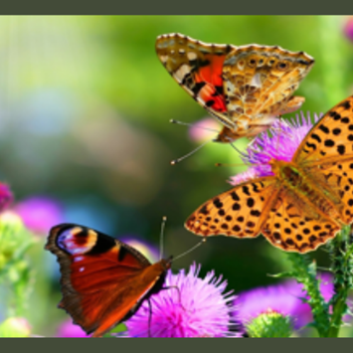

On May 13th the talk will be

#### [Seeing the Urban Forest for the Trees](https://mountpleasantlibrary.evanced.info/signup)

Trees are well-known for their aesthetic value, and for providing important habitat for wildlife and food for pollinators. **But did you know** they also play a critical role in regulating the climate of our communities and can be a really important tool for mitigating climate change and reducing electricity consumption?

Presented by CAC member Andy Reinmann, Assistant Professor of Environmental Science at the CUNY Advanced Science Research Center and Hunter College

and the 3rd talk on Tuesday May 25 will be

**Composting - it's Easy!**

Composting is a great way to recycle leftover food and plant waste. The equipment needed is simple, and it takes very little effort. As well as reducing your garbage volume (and smelly, wet food waste), you can make some good stuff (compost!) to add to your garden beds, lawn, and potted plants.

Presented by CAC chairperson Helen Meurer, Master Composter and Recycler